МИНИСТЕРСТВО ОБРАЗОВАНИЯ РЕСПУБЛИКИ БЕЛАРУСЬ

УЧРЕЖДЕНИЕ ОБРАЗОВАНИЯ

“БРЕСТСКИЙ ГОСУДАРСТВЕННЫЙ ТЕХНИЧЕСКИЙ УНИВЕРСИТЕТ”

**ИНТЕЛЕКТУАЛЬНЫЕ ИНФОРМАЦИОННЫЕ ТЕХНОЛОГИИ**

ОТЧЁТ

По лабораторной работе № 1

Выполнил:

Студент группы ИИ-22

Копанчук Евгений Романович

Проверил:

Рыжов А. С.

Брест – 2023

**Ход работы**

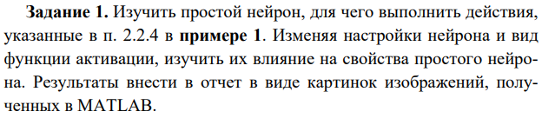

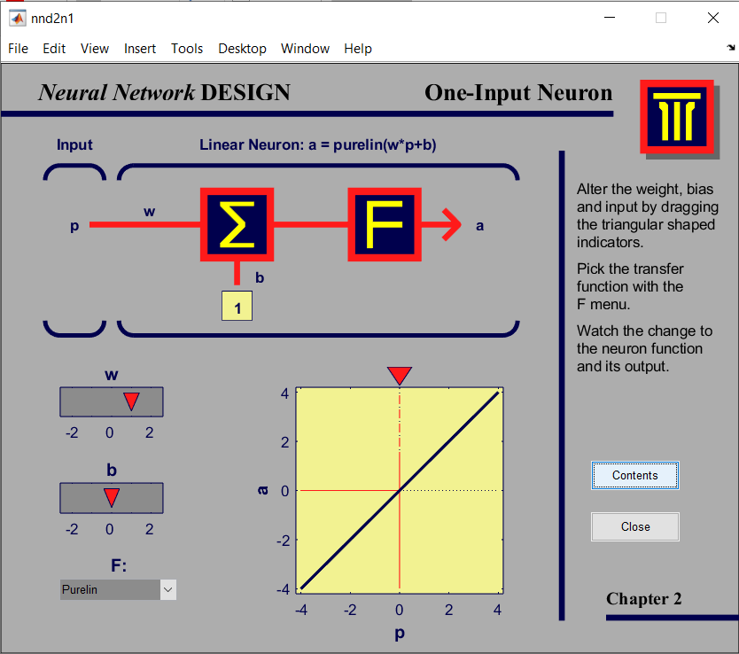

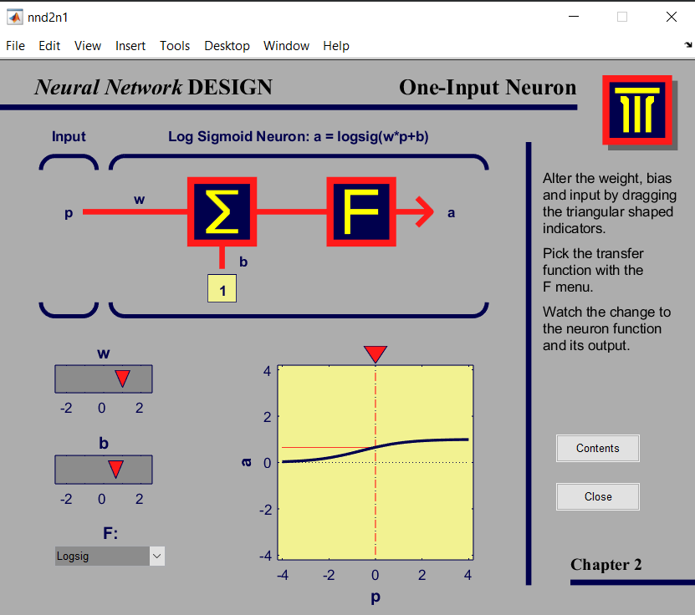

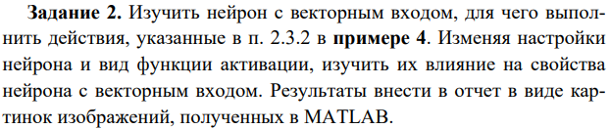

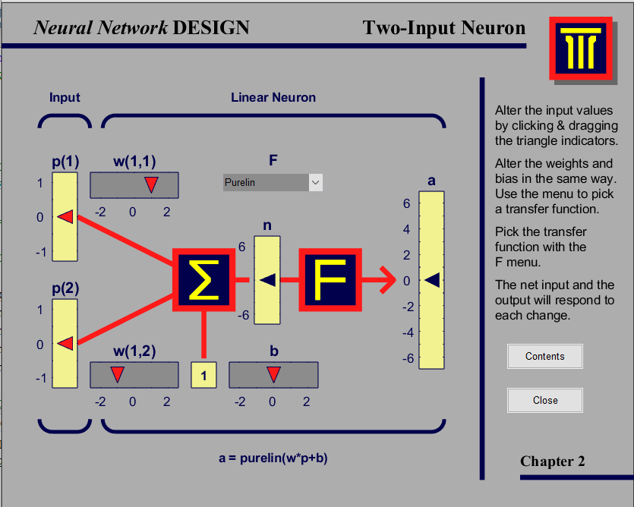

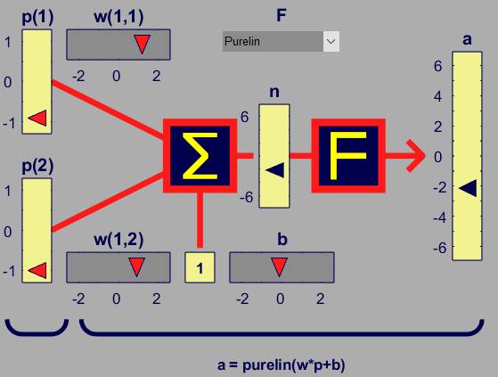

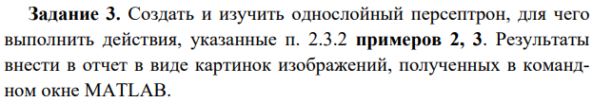

|  |  |
| --- | --- |
| >> clear, net = newp([-2 2;-2 2],1);  >> net.IW{1,1} = [-1 1];  >> net.b{1} = [1];  >> p1 = [1; 1];  >> a1 = sim(net,p1)  a1 =  1  >> p2 = [1; -1];  >> a2 = sim(net,p2)  a2 =  0  >> p3 = {[1; 1] [1; -1]}  p3 =  1×2 cell array  {2×1 double} {2×1 double}  >> a3 = sim(net,p3)  a3 =  1×2 cell array  {[1]} {[0]}  >> |  |

|  |  |
| --- | --- |
| >> clear, net = newp([-2 2;-2 2;-2 2],2);  >> net.IW{1,1} = [3 1 2; 1 4 0];  >> net.b{1} = [2;5];  >> p1 = [1; 3; 2];  >> a1 = sim(net,p1)  a1 =  1  1  >> p1 = [1; 3; -5];  >> a1 = sim(net,p1)  a1 =  0  1  >> |  |

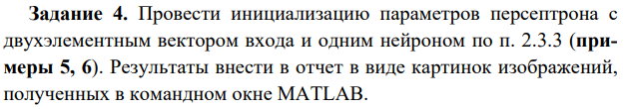

|  |  |
| --- | --- |
| >> clear, net = newp([-2 2;-2 2],1);  >> net.inputweights{1, 1}  ans =  Neural Network Weight  delays: 0  initFcn: 'initzero'  initSettings: (none)  learn: true  learnFcn: 'learnp'  learnParam: (none)  size: [1 2]  weightFcn: 'dotprod'  weightParam: (none)  userdata: (your custom info)  >> wts = net.IW{1,1},  bias = net.b{1}  wts =  0 0  bias =  0  >> net.IW{1,1} = [3, 4]; net.b{1} = 5;  wts = net.IW{1,1}, bias = net.b{1}  wts =  3 4  bias =  5  >> net = init(net); wts = net.IW{1,1}, bias = net.b{1}  wts =  0 0  bias =  0  >> |  |

|  |  |
| --- | --- |
| >> net.inputweights{1,1}.initFcn = 'rands';  >> net.biases{1}.initFcn = 'rands';  >> net = init(net);  >> wts = net.IW{1,1}, bias = net.b{1}  wts =  0.8116 -0.7460  bias =  0.6294  >> |  |

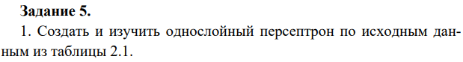

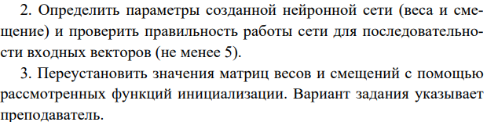

|  |  |
| --- | --- |
| >> clear, net = newp([-2 2;-2 2],3);  >> wts = net.IW{1,1},  bias = net.b{1}  wts =  0 0  0 0  0 0  bias =  0  0  0  >> p1 = {[1; 1] [1; -1] [-1; 1] [-1; -1] [-1; 0]}  p1 =  1×5 cell array  {2×1 double} {2×1 double} {2×1 double} {2×1 double} {2×1 double}  >> a1 = sim(net,p1)  a1 =  1×5 cell array  {3×1 double} {3×1 double} {3×1 double} {3×1 double} {3×1 double}  >> net.inputweights{1,1}.initFcn = 'rands';  net.biases{1}.initFcn = 'rands';  >> net = init(net);  >> wts = net.IW{1,1},  bias = net.b{1}  wts =  -0.4430 0.9298  0.0938 -0.6848  0.9150 0.9412  bias =  0.8268  0.2647  -0.8049  >> |  |